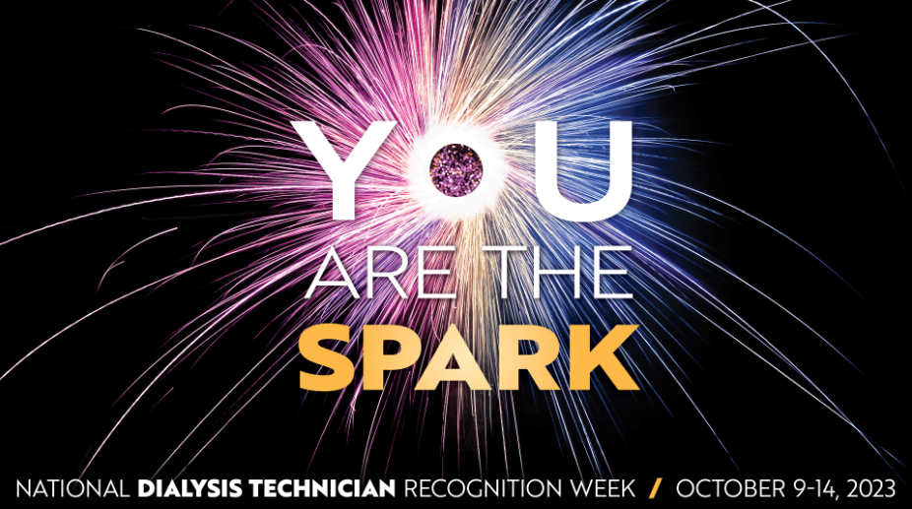

Ways that the National Association of Nephrology Technicians / Technologists can help you celebrate National Dialysis Technician Recognition Week:
Go to www.DialysisTech.net/about-nant/national-recognition-week-for-hemodialysis-technicians to download:
Certificates for supervisors to give to dialysis technicians
Certificates for patients to give to their dialysis technician
Posters to promote National Dialysis Technician Recognition Week

- NANT will be running social media ads to promote National Dialysis Technician Recognition Week (NDTRW)
- NANT and AAKP are collaborating on promoting this week to dialysis patients so that they can show their own technician how important they are to their wellbeing.
- NANT can provide DTX registration vouchers to supervisors to use as prizes in internal contests
- NANT will be promoting NDTRW to its member starting the first week in September
- Special issues of NANT News will be distributed each day of NDTRW

